Research about the outfit managing app

To have more creative ideas about this kind of app and drawing on successful examples. I find four different apps have the similar design with our app to compare with our app and find differences.

No.1 Chicisimo

This app is an app about women’s fashion. There is no relation to weather. But it still has some similar place with our app.

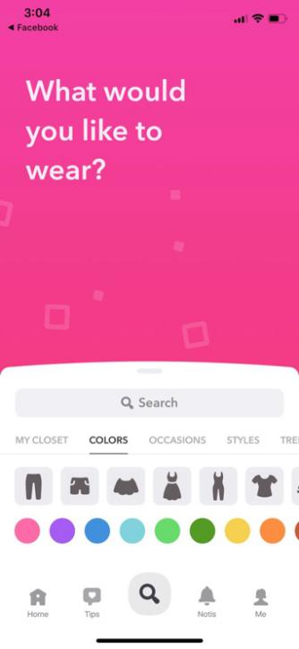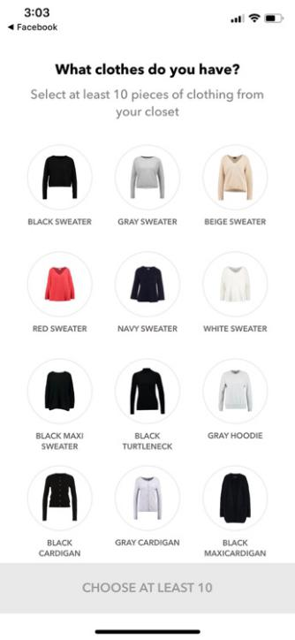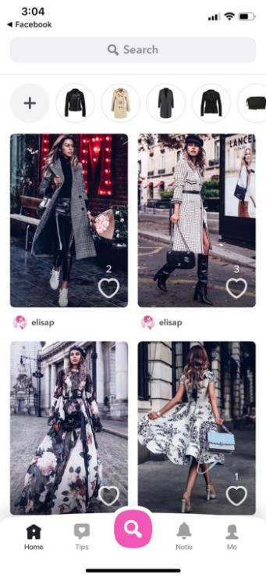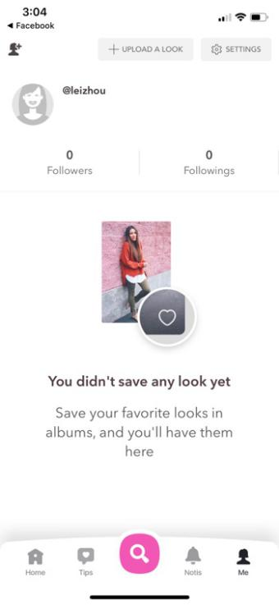

The interface of what to wear is really close to our app. With the choice of colour and the type of outfit. The app also gives some fashion show of what to wear. You can also have your account and upload a look in this app. This app also do a search bar to find what to wear.

No.2 Jacket

This app is more close to our app. It has information about the weather, temperature and wind level. But what different is that it doesn’t have suggestions about what to wear. This app just tell you do you need to wear a jacket.

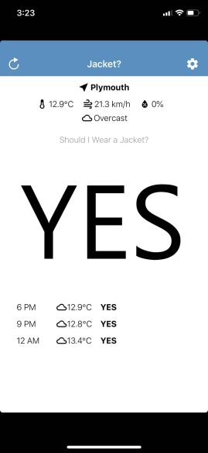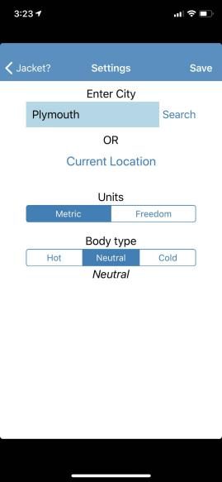

This app also has a search bar to search your position. It can help you to know local climate.

No.3 Wear Weather

This app looks like an advanced version of the app ‘Jacket’. It added the menu and more suggestions about what to wear everyday. There also has a new weather forecast function. This function make the app no longer limited what to wear today. People use this app can prepare what to wear tomorrow.

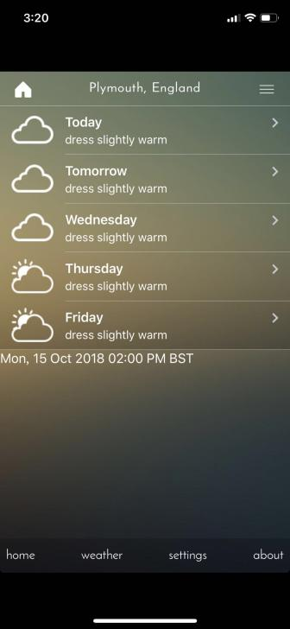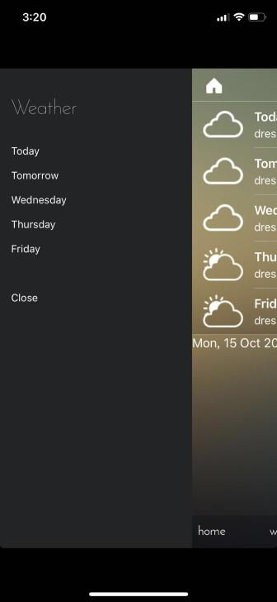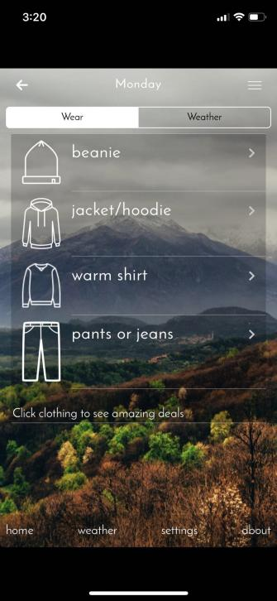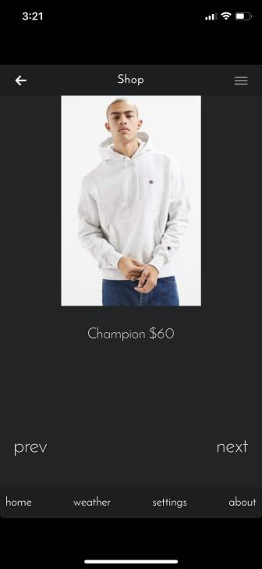

The function of suggestions about what to wear on this app is more like a shopping store. It has a link to a shopping website.

No.4 What to wear

This app is the easiest app of the four apps. It just only has one interface. It’s easy but convenience and obvious. With automatic positioning function and suggestions about what to wear.

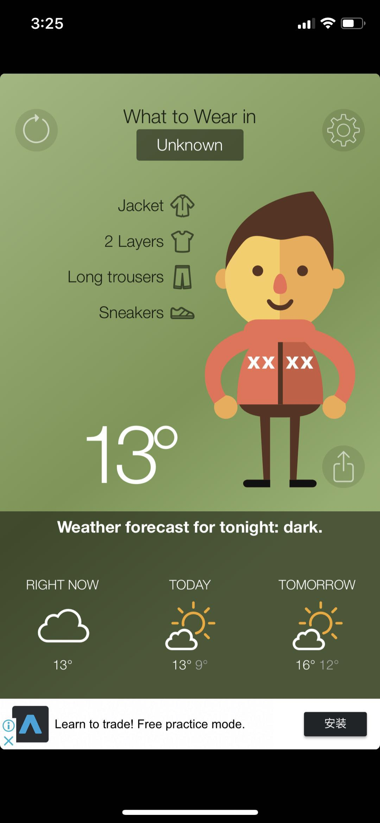

But this app can’t achieve live update.It needs users manual refresh by refresh button.And this app is also too simple.

These four apps are apps look similar to our app. But they are all mobile apps. I think we can learn some stuff from these apps and do much better.